Project Design
This research followed the developmental project design to build ReqMatic, a centralized online system for requesting barangay documents. The system is developed to provide residents with a convenient and accessible way to request barangay documents, while barangay staff can efficiently process and notify the residents about the status of their requests. By focusing on the document request workflow, ReqMatic eliminates the delays and inefficiencies of traditional document request process, ensuring that request records are properly managed and requests are processed in a timely and transparent manner.

1. System Architecture
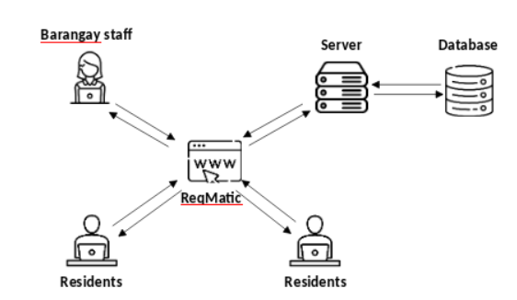
Figure ???: System Architecture
The proposed system architecture for the Barangay Online Document Request System, named ReqMatic, follows a client-server model that connects residents, barangay staff, and the central server with its database. Residents access the system through a web interface where they can submit requests for official barangay documents such as certficate of indigency, residency, employment, and other official documents. Their requests are transmitted securely to the server, ensuring accessibility from any device with an internet connection. This eliminates the need for physical visits, making the process more convenient and efficient for the community.
On the other side, barangay staff also utilize the same web interface to manage incoming document requests. Through their accounts, they can verify resident information, update the status of requests, and approve or deny submissions. The server acts as the central hub, processing the interactions between users and storing all relevant data in the database. This ensures that request records are maintained systematically, minimizing errors and allowing barangay officials to easily track pending, approved, and completed requests.
The database component stores all essential data, including resident profiles, document request records, and processing logs. The server continuously communicates with the database to fetch, update, and store information as needed. This integration ensures data consistency and reliability, supporting the system’s overall functionality. By connecting residents, barangay staff, the server, and the database in a unified architecture, ReqMatic streamlines the process of document requests, enhances transparency, and promotes better service delivery at the barangay level.

2. Context Diagram
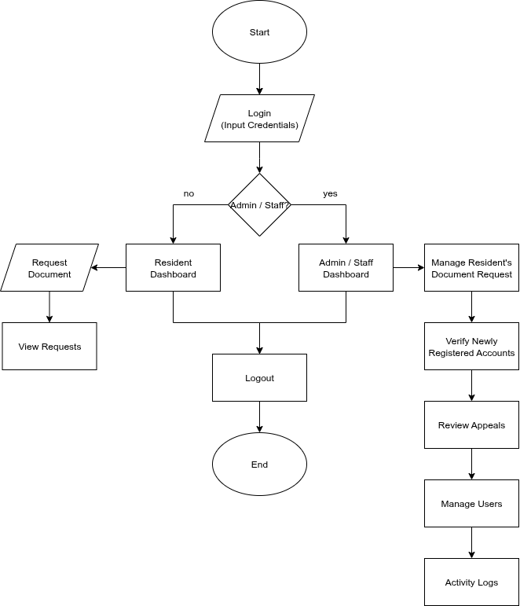
Figure ???: Website Diagram
The Barangay Online Document Request System is designed to provide residents and barangay staff with a convenient and efficient way to manage official documents. The system begins with a login process where users enter their credentials, after which they are directed to their respective dashboards depending on their role. For residents, the dashboard allows them to request barangay documents online and view the status of all their requests. This feature reduces the need for physical visits to the barangay office while ensuring that residents can easily monitor the progress of their applications.
On the other hand, barangay staff and administrators are given a wider range of functions that support the management of requests and accounts. From their dashboard, they can approve or reject document requests, verify newly registered accounts, review appeals, manage users, and check activity logs for accountability. Both residents and staff can securely log out after completing their tasks, ensuring that sessions are properly closed. By offering role-specific features, the system promotes efficiency, transparency, and accessibility in handling barangay services.

3. Database Design
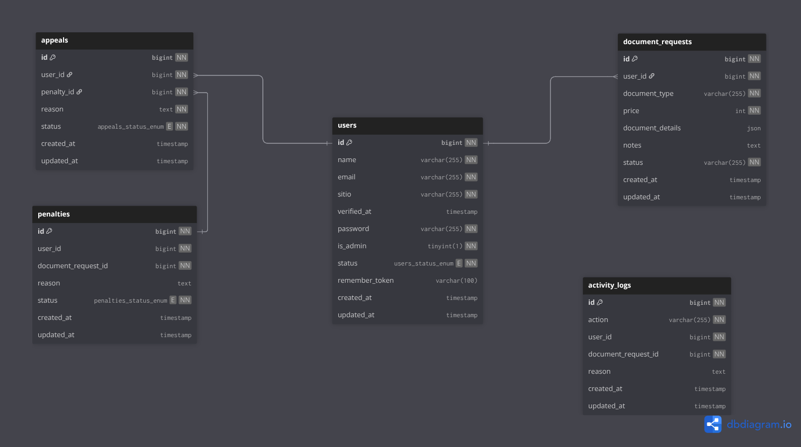
The database design of the Barangay Online Document Request System is structured to ensure efficient management of user information, document requests, penalties, appeals, and activity logs. At the core of the system is the users table, which stores essential resident and staff details such as name, email, sitio, password, verification status, and role identification (resident or admin). This serves as the foundation of the system since every transaction and record is linked to a specific user. The document_requests table is directly associated with users and records the details of each request, including document type, price, additional notes, and request status, allowing residents to track their applications and enabling staff to manage approvals or rejections effectively.
To handle violations and disciplinary actions, the penalties table was introduced. Each penalty record is linked both to a user and a specific document request, ensuring transparency and accountability. If residents wish to contest their penalties, the appeals table comes into play, where users can submit reasons for appeal, and barangay staff can update the status of the case. To maintain a record of all actions within the system, the activity_logs table documents every significant event such as request submissions, approvals, penalties, and appeals. This feature ensures traceability, making the system more reliable and secure. Overall, the design follows normalization principles by minimizing redundancy and maintaining clear relationships across entities, resulting in a structured and well-organized database.

4. User Interface (UI) Design
The UI/UX Designer produces the visual layout and interaction flow of the Barangay Online Document Request System to make it functional, simple, and user-friendly. The design emphasizes clarity and ease of use, ensuring that residents can conveniently submit and track their requests while barangay staff can manage approvals, penalties, and accounts efficiently. Consistent layouts, clear action buttons, and readable typography guide users smoothly through their tasks, while the responsive design ensures accessibility across devices such as desktops, laptops, and mobile phones. This approach not only supports the system’s core functions but also provides a seamless and engaging user experience.

4.1. Desktop Web Application Layout
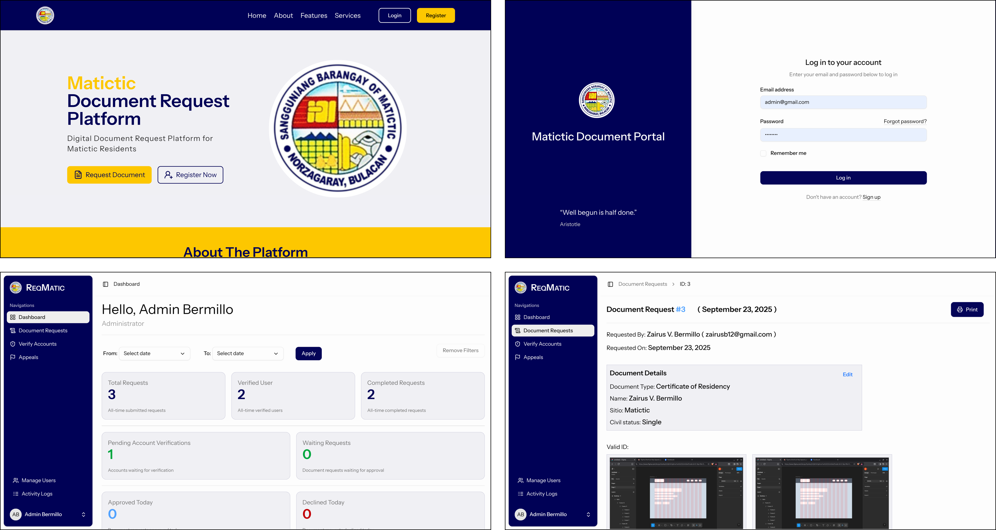

4,2. Mobile Web Application Layout
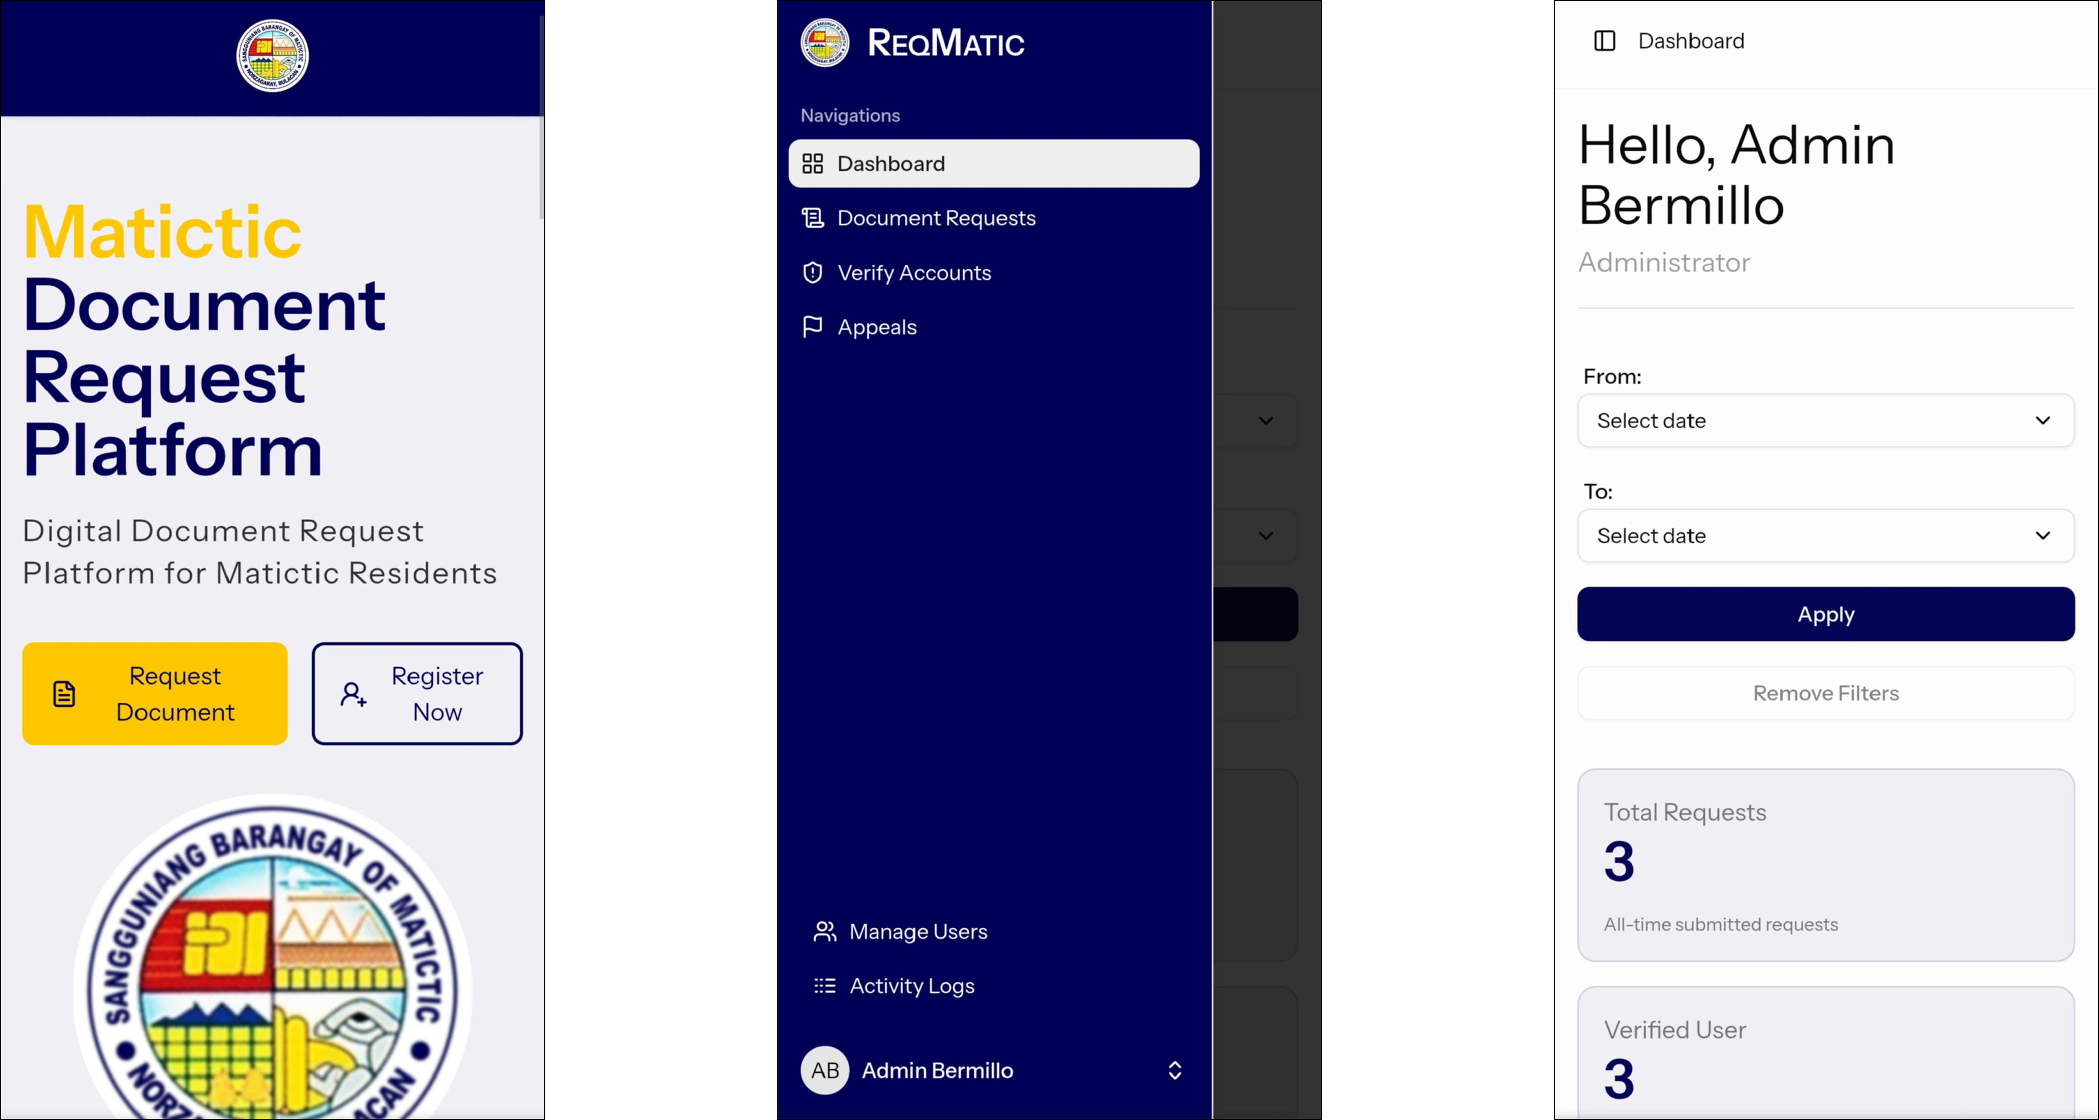

5. Technical Specifications
The system is developed to facilitate the smooth interaction between barangay staff and residents through an online platform for document requests. It is based on a client-server deployment, where the administrator or staff maintains and manages the system’s content, while residents access the website to submit requests, track the status of their applications, or view related updates. Once a resident or staff performs an action (e.g., submitting a request, approving or rejecting an application, or applying a penalty), a request is sent to the server.
The server then processes the request and communicates with the database to either fetch or update the required information, after which the result is sent back to the website interface. This ensures that residents can instantly see the status of their requests, while staff can efficiently manage records and activities. This design allows the system to run smoothly and ensures that all user data, document requests, penalties, appeals, and logs remain synchronized and up to date. By integrating both resident and staff operations in a secure and responsive platform, the system provides a reliable tool for managing barangay transactions.

